**DAILY ONLINE ACTIVITIES SUMMARY**

|  |  |  |  |  |  |  |  |  |
| --- | --- | --- | --- | --- | --- | --- | --- | --- |
| **Date:** | **26-05-2020** | | | | | **Name:** | **Deeksha D Poojary** | |
| **Sem & Sec** | **VIII Semester & A Section** | | | | | **USN:** | **4AL16CS026** | |
| **Online Test Summary** | | | | | | | | |
| **Subject** | | **Big Data Analytics** | | | | | | |
| **Max. Marks** | | **30** | | **Score** | | | **60** | |
| **Certification Course Summary** | | | | | | | | |
| **Course** | **Introduction to Hadoop** | | | | | | | |
| **Certificate Provider** | | | **Great Learning** | | **Duration** | | | **4 Hours** |
| **Coding Challenges** | | | | | | | | |
| **Problem Statement: Program 1: Find no of sub-arrays, Program 2: Find permutation of the String.** | | | | | | | | |
| **Status: COMPLETED** | | | | | | | | |
| **Uploaded the report in Github** | | | | | **YES** | | | |
| **If yes Repository name** | | | | | **deekshapoojari** | | | |
| **Uploaded the report in slack** | | | | | **YES** | | | |

Online Test Details: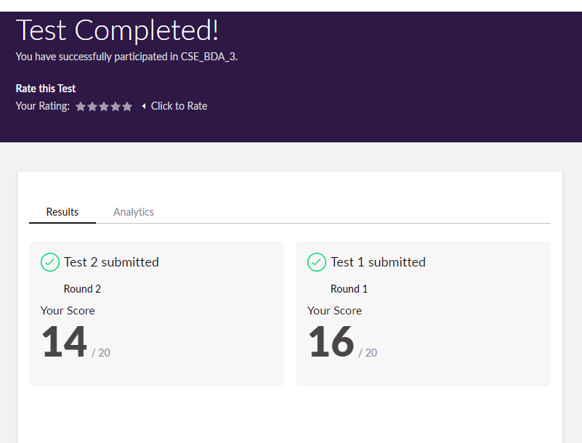

Certification Course Details:



Coding Challenges Details:

|  |
| --- |
|  |
|  |
|  |
|  |
|  |
|  |
|  |
|  |
|  |
|  |
|  |
|  |
|  |
|  |
|  |
|  |
|  |
|  |
|  |
|  |
|  |
|  |
|  |
|  |
|  |
|  |
|  |
|  |
|  |
|  |
|  |
|  |
|  |
|  |
|  |
|  |
|  |
|  |
|  |
|  |
|  |
|  |
|  |
|  |
|  |
|  |
|  |
|  |
|  |
|  |
|  |
|  |
|  |
|  |

**Program1:**

**#include <stdio.h>**

**#include <string.h>**

**void swap (char *x, char *y)**

**{**

**char temp;**

**temp = *x;**

**\*x = *y;**

**\*y = temp;**

**}**

**void permute(char *a, int i, int n)**

**{**

**int j;**

**if (i == n)**

**printf("%s\n", a);**

**else {**

**for (j = i; j <= n; j++)**

**{**

**swap((a + i), (a + j));**

**permute(a, i + 1, n);**

**swap((a + i), (a + j));**

**}**

**}**

**}**

**int main()**

**{**

**char a[40];**

**int n;**

**printf("Enter a string: ");**

**scanf("%s", a);**

**n = strlen(a);**

**printf("\nPermutaions:\n");**

**permute(a, 0, n - 1);**

**getchar();**

**return 0;**

**}**

**Program 2:**

**#include <bits/stdc++.h>**

**using namespace std;**

**void cntArray(int A[], int N)**

**{**

**int result = 0;**

**int frequency[N + 1] = { 0 };**

**for (int i = 0; i < N; i++) {**

**frequency[A[i]]++;**

**}**

**for (int i = 1; i <= N; i++) {**

**int frequency_of_i = frequency[i];**

**result += +((frequency_of_i) * (frequency_of_i + 1)) /**

**2;**

**}**

**cout << result << endl;**

**}**

**int main()**

**{**

**int i,N=0,A[20];**

**cout<<"Enter no of elementd : ";**

**cin>> N;**

**for(i=0;i<N;i++)**

**cin>>A[i];**

**cntArray(A, N);**

**return 0;**

**}**